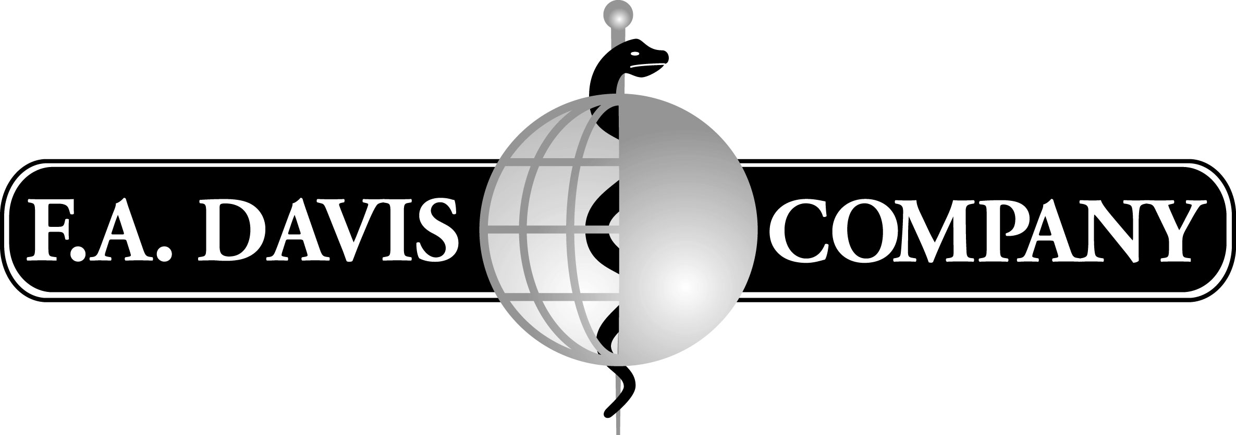

**Developmental Editor and Digital Products Manager**

F.A. Davis, an independent Nursing, Medicine, and Health Sciences publisher since 1879, is dedicated to providing print, mobile, and web resources for students and professionals. The F.A. Davis mission is to listen carefully to health science educators and their students, analyze the prevailing competition, identify capable authorship, and then publish the finest texts, references, and resources in a wide variety of formats. Our goal is to assert leadership in this market, satisfying the timely need for the most up-to-date, accurate, and informative resources from which students can master their coursework.

F.A. Davis Company remains as it started over 130 years ago...a family-managed, independent publisher in touch with the grass roots synergy of its customers. Visit us at [www.fadavis.com](http://www.fadavis.com)

We offer our employees a full range of benefits including medical, dental, life insurance, wellness programs, discounted gym membership, STD, LTD, 401(k) and paid time off. EOE.

**Position summary:**

The Developmental Editor and Digital Products Manager (DE/DPM) will serve as primary developmental editor for, and manager of, digital products in multiple Health Profession disciplines. The DE/DPM must work closely with the acquisitions editors, authors, and assigned freelance DEs and development vendors to carry out the publishing plan for each title. Active collaboration with the Digital Publishing (DP) and Production departments is required to successfully create digital products, such as video, web, audio, mobile, and custom software.

**Position responsibilities:**

*Human Resources*

* Serve as primary developmental editor for digital products in Health Professions / Medicine and oversee the execution of each developmental plan so it matches the expectation at signing
* Act as main liaison with the Digital Publishing (DP) and Production departments for digital products (such as video, web, audio, mobile, custom software development)
* Coordinate freelance DE work on digital products. Ensure that DEs successfully implement development plan
* Identify and manage outside vendors to help with developmental workload as needed
* Train Developmental Editor, Electronic Products, as needed
* Assist DP project coordinators to direct the work of outside DP vendors

*Projects*

* Advise Director of Content Development regarding workflow of all HPM projects as they proceed through Digital Publishing and Production. Report status of all assigned projects on a regular basis via company-wide database and monthly departmental meetings
* Work with acquisition editors from inception of project through the development and production cycles to educate potential, and signed, authors about the publication process; includes participation in Product Launch meetings
* Collaborate with acquisition editors to identify/suggest appropriate digital products; request Electronic Application Development Estimate (EADE) from Digital Publishing department for each project; monitor changes to the EADE
* Create and monitor development schedules. Ensure that deadlines are clearly communicated to authors/SMEs, freelance DEs, and development vendors. Act as a troubleshooter as problems arise
* Direct and help authors/contributors to assemble all of the elements of the manuscript in the desired form; Assist authors and freelance DEs with art development process.
* Prepare and release final manuscript to Production and Digital Publishing; Review all art programs (files, scrap, logs) submitted by authors, freelance DEs, and development vendors before they are transmitted to Production
* Monitor developmental, art, and DP budgets for titles overseen
* Review and provide feedback to Digital Publishing on software requirements specifications documents and all software versions (Beta etc.) and web sites as well as rough cut through final video clips
* Review page proof and art proof and CD packaging received from Production
* Set up, coordinate, and travel for video/photo shoots and/or studio time for audio projects as needed
* Present/assist with discussion of selected digital products at New Product and Checkpoint meetings; present new titles to sales force at annual sales meeting as assigned
* Travel to annual company sales meeting as required; attend academic conferences and visit educational programs on campuses as needed

*Policies and Procedures*

* Coordinate relationship between the production, art, design, and developmental process with the author
* Assist in the maintenance of consistent and efficient developmental procedures
* Collaborate with DP managers to ensure that current policies are still effective and are maintained in an effective manner

**Role qualifications:**

* Bachelor’s Degree
* Minimum 3-5 years developmental experience
* Excellent written and verbal communications skills
* Instructional design and interactive design knowledge strongly desirable
* Strong computer/electronic skills required: MS Office Suite (Word/PowerPoint/Excel) and Adobe Acrobat. Working knowledge of Adobe Photoshop and Illustrator desirable. Database work helpful.
* Superior interpersonal skills
* Willingness to travel as needed
* A well-developed sense of resourcefulness, adaptability, and humor

**Physical Demands and Work Environment:**

* Work conducted in normal office setting
* Frequent communications, verbal and written
* Frequent sitting and/or standing, walking and climbing stairs
* Repetitive movement of hands and fingers – typing and/or writing
* Some travel involved

**Contact Information:**

* Submit resume with cover letter to: [mms@fadavis.com](mailto:mms@fadavis.com)
* Fax: 215-568-5065